In Medias Res
“In the Middle of Things”
The Newsletter of the Media Ecology Association
Fall, 2001 Vol. 3, No. 1

President’s Message

Conventional Wisdom

Lance Strate, MEA President

Fordham University

Wisdom is about human relationships, it is about persons and presence. Conventions are environments that enable persons to come together for face-to-face dialogue, to be in one another's presence as we participate in intellectual exchange, to form new professional relationships and renew old ones. This brand of conventional wisdom was in abundant supply during our Second Annual MEA Convention, whose success was due to the Herculean efforts of Convention Coordinator Janet Sternberg, Associate Coordinator Linda Burns, and the many volunteers who stepped forward on behalf of our Association. A great debt is also owed to our host, New York University's Department of Culture and Communication, headed by Neil Postman, for the generous support they have shown us, and for the magnificent facilities secured for the event. Having completed two conventions now, I find especially encouraging the high level of commitment that has been demonstrated by all involved, from students to senior scholars and intellectual stars.
Next year's MEA Convention will again be held in New York City, the host this time being Marymount Manhattan College. The convention will be held on the weekend of June 21-23, 2002, so be sure to reserve that date. David Linton and Laura Tropp will be Co-Coordinators of the Convention, they have some innovative ideas, and I believe the results will be quite stimulating.
As we look ahead to the 2002 convention, and beyond, I believe that we have a number of factors that we need to consider, and I would like to get the input and feedback of the MEA membership on them:
• The Length of the Convention. The first two conventions were two days long, each day fully scheduled. The 2002 convention will be three days long, and the volume of submissions we have been receiving clearly justifies the extra day. And it is not unheard of for conferences to run over four days or longer. Longer conventions are more expensive, however, which may result in higher registration fees, or reduced services. Longer meetings may mean more money spent on room and board. And longer conventions make for a more fragmented group, as more people will be less likely to remain for the duration of the event. But longer conventions could allow for more participation, more special events, more opportunities for discussion and interaction, and a more leisurely pace.
• Time Allotments. What is the optimal time limit for presenting a paper? Should presenters be allowed as much time as they need? A limited period of time that is longer than the fifteen minute norm? Or should we ask for even more concise presentations in order to accommodate more participants (with hard copies of the papers made available for interested audience members)? (Cont. on p. 11)

In Medias Res is a benefit for MEA Members.
Inquiries about and/or contributions to this
newsletter should be addressed directly to its
Editor. The images used herein were obtained
from IMSI’s MasterClips (c) Collection, 75
Rowland Way, Novato, CA 94945. This
newsletter was supported by a generous grant
from Megan Roberts, Chair of TV-Radio Dept.,
Park School of Communications, Ithaca College.
Editor
Raymond Gozzi, Jr. Ithaca College
gozzi@ithaca.edu
MEA Executive Committee
President, Lance Strate, Fordham University
Vice President, Casey M.K. Lum, William
Paterson University
Treasurer, Thomas F. Gencarelli, Montclair State
University
Executive Secretary, Susan Barnes, Fordham
University
Historian, Janet Sternberg, New York University
MEA Board of Directors
Mary Ann Allison, Allison-Labue Group
James W. Carey, Columbia University
Neil Postman, New York University
Lance Strate, Fordham University
Appointed Officers
Internet Strategist, Mary-Ann Allison, Allison-
Labue Group
List Owner, Stephanie B. Gibson, Univ. of
Baltimore
Webmaster, Paul Kelly, Ontario, Canada
Web Editor, James Morrison, MIT
Art Director, Mark Lipton, Vassar College

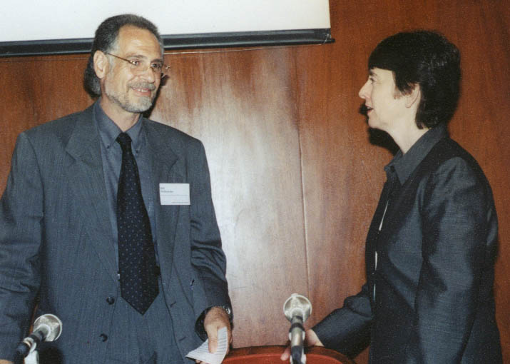

Bill Petkanis confers with Camille Paglia

All photos © 2001 Robert Francos
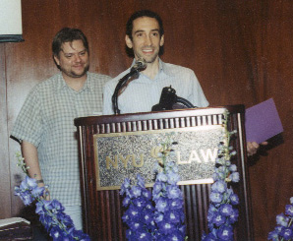

Douglas Rushkoff accepts an award presented by Michael Grabowski.

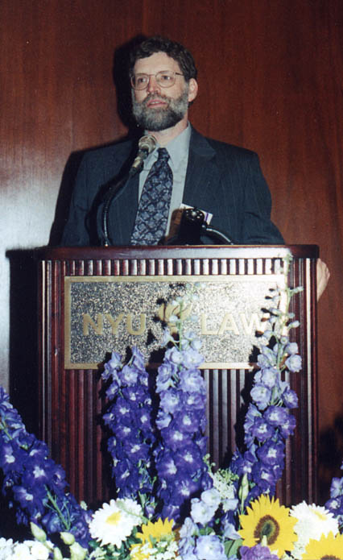

Joshua Meyrowitz

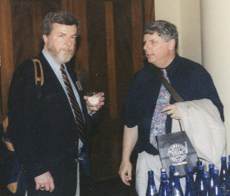

Jim Morrison and Ray Gozzi

From the Convention Coordinator

Dr. Janet Sternberg

In New York City's Greenwich Village, on Friday and Saturday, June 15-16, 2001, media ecology aficionados gathered from near and far to attend the Second Annual MEA Convention, sponsored by New York University's Department of Culture and Communication. As Convention Coordinator, as MEA Historian and as a recent NYU graduate, I'm triply pleased and proud to report on this memorable event.
Now, although media ecologists don't ordinarily indulge in quantitative analysis, let me provide a few statistics about who attended the Convention. As developer and keeper of the recently-inaugurated MEA membership database, I had occasion to compile some figures that seem worth sharing. Counting panelists, moderators, invited speakers, volunteers, and audience members, a total of 123 people attended this year's event, roughly a quarter of whom were students. In terms of geographic distribution, it's hardly surprising that the majority (64% to be precise) hailed from New York (city and state); nevertheless, participants also came from 13 other states (CO, CT, DC, FL, MA, MD,
ME, MN, NJ, NJ, PA, TX, and WI), as well as three countries besides the US (Canada, France, and the UK). Participants' affiliations spanned no fewer than 44 educational institutions, including 15 "University of's" (four abroad, the rest covering nine US states). About half the participants were affiliated with schools in the New York metropolitan
(Continued on p. 4)

Convention Notes

Raymond Gozzi, Jr.

As usual, I took notes at the MEA convention, trying to preserve some of the gems of insight which flashed by so quickly. Here is a selection from my notes. If you are not included, don’t take it personally—I probably missed your session!
* * * *
Reality is open source. A lot of it is software we think is hardware. But it is still programmable. We have an opportunity to forge an interactive, open source reality, mainly through media. There is a battle for control over the new reality before it gets locked down. People forget--we are living in a picture. The picture can be changed. How do we retain this insight?
Douglas Rushkoff, NYU

The power of hegemony--we learned how to be rebels from government licensed media.
Edmund Chibeau, Eastern Connecticut State University (Continued on p.4)

Coordinator (cont.)

area: a quarter from NYU, with the next largest groups coming from Columbia University, Fordham University, Marymount Manhattan College, Brooklyn College, Hofstra University, and SUNY Stony Brook. And in addition, a dozen participants listed affiliations with businesses, press, and other non-academic organizations. What these numbers suggest to me is that the MEA is reaching considerably beyond the geographic and institutional origins of its founding members, a commendable trend to be further encouraged.
Just prior to the closing performance came a moment dear to my heart, when we paused to express our thanks to those who helped made this Convention possible. Not only did we benefit from the cooperation of staff from NYU's Department of Culture and Communication and from the office of Conferencing and Special Events at the School of Law, but we also were assisted by many individuals whose contributions were equally essential in making the event run smoothly. So on behalf of the MEA, we presented tokens of our collective appreciation to Linda Burns, who more than earned the title of "Most Valuable Player" on the Convention team, as well as to our video coordinator, up-and-coming filmmaker Michael Grabowski; to our devoted photographer, Robert Francos (some of his photos accompany this text, with more to appear in future on the MEA Web site); and to our goddess of presentation support equipment, Liat Gilead. We also praised our cadre of dedicated volunteers, led by the top-notch NYU Convention Organizing Committee: Cheryl Casey, Sal Fallica, Tom Harkins, Christina Kotchemidova, and Jennifer Warren. And catching me completely by surprise, Lance Strate and Thom Gencarelli presented me with a plaque commemorating my participation in this year's Convention, a most special memento that I'll treasure always, along with many happy memories of this marvelous event.
The MEA was fortunate indeed to receive financial support for this year's Convention not only from NYU, the host institution, but also from other organizations, principally three co-sponsors: the School of Communication Design at the University of Baltimore, the Department of Communication and Media Studies at Fordham University, and the Communication Arts Department and the Theresa Lang Center for Producing at Marymount Manhattan College. Additional funding was provided by the School of Communication at Hofstra University and by Mercy College, as well as by Hampton Press and MIT Press. We're extremely grateful for this support, so vital to the success of our Convention, and we hope such sponsors will come forward again to collaborate on future
MEA endeavors. The schedule remains posted on the MEA Web site at
< http://www.media-ecology.org/
events_conference2_schedule.rtf>
We also look forward to future publication on our Web site of the 2001 Convention Proceedings, edited by Donna Flayhan. Stay tuned, and see y'all next year! :)

Convention Notes (cont.)
“Smart cities” are a visionary urban development--a conscious effort to use information technology to transform urban life in significant and radical ways, not incremental.
Gary Gumpert, Communication Landscapers; and Susan Drucker, Hofstra University

The movie theater is the altar of technological society. Cinema is the culture’s chief mythmaker.
Read Mercer Schuchardt, NYU (Cont. on p. 5)

Convention Notes (cont.)
This is an age of book destruction. As information is reformatted into digital form, the originals are thrown away.
Richard Bucci, Mark Twain Project, Univ. of California, Berkeley

New libraries called “idea stores” are being built in poor towns in Britain, in shopping centers and other accessible places. They are comfortable, so people will stay and be more likely to read and browse. They are quiet toward the back, chatty up front. Librarians walk the floors to help people. They give many courses, have a cafe.
Neil Kleinman, University of Baltimore

The hidden factor in visual communication is linear perspective. This has rules and procedures and needs to be learned. Perspective and print both rely on left-brain functions of sequencing and logic.
Robert Hall, Flagler College

Electric media combine the involvement of orality with the distance of literacy. They produce a paradoxical situation of uninvolved involvement. This leads to related paradoxes such as intimate anonymity and personalized impersonality. Perhaps these are more fruitfully considered as unresolved dialectical tensions.
Raymond Gozzi, Jr., Ithaca College

When one element of a signifying opposition is obliterated, the other element is impossible to signify. It becomes an indistinguishable part of reality. This perhaps has happened with cheerfulness in America. Its opposite has disappeared, and cheerfulness has become central to media and advertising strategies.
Christina Kotchemidova, NYU

Language
Words were the first concepts--a phase attractor for different percepts.
Robert Logan, University of Toronto

The symbolic functions of language are lightly and tentatively overlaid on the sign-functions of language. The use of writing holds the signalic paradigm in check. We should be concerned with the decline of writing, because this will lead to a resurgence of the signalic paradigm, with functions like magical and superstitious use of language.
Christine Nystrom, NYU

In their self-motivated writing, students are orally biased. They use writing for expressive and thereapeutic functions. For them words are not separate from their creator, and are embedded in context. This is different from school-based writing.
Lori Ramos, William Paterson University (Cont. on p. 6)

The Media Ecology Association is proud to announce the winners of its 2001 Awards:
The winner of the Marshall McLuhan Award for Outstanding Book in the Field of Media Ecology is Thomas J. Farrell, for Walter Ong's Contributions to Cultural Studies: The Phenomenology of the Word and I-Thou Communication (Cresskill, NJ: Hampton Press, 2000).

The winner of the Walter Benjamin Award for Outstanding Article in the Field of Media Ecology is Pablo J. Boczkowski, for "Mutual Shaping of Users and Technologies in a National Virtual Community" (Journal of Communication, Vol. 49, No. 2, Spring 1999).

The winners of the Lewis Mumford Award for Outstanding Scholarship in the Ecology of Technics are Jay David Bolter and Richard Grusin, for Remediation: Understanding New Media (Cambridge, MA: MIT Press, 1999).

The winner of the Susanne K. Langer Award for Outstanding Scholarship in the Ecology of Symbolic Form is Raymond Gozzi, Jr., for The Power of Metaphor in the Age of Electronic Media (Cresskill, NJ: Hampton Press, 1999).

The winner of the John Culkin Award for Outstanding Praxis in the Field of Media Ecology is Douglas Rushkoff, for The Merchants of Cool television documentary, written, produced, and narrated for the PBS program Frontline, aired February 26, 2001.

The winner of the Harold A. Innis Award for Outstanding Thesis or Dissertation in the Field of Media Ecology is Lori Ramos, for Self-Initiated Writing Practices and Conceptions of Writing Among Young Urban Adolescents, a doctoral dissertation completed at New York University in 2000, under the direction of Christine Nystrom.

The winner of the Jacques Ellul Award for Outstanding Media Ecology Activism is Dennis Gallagher of Regis University, for his work on the Denver City Council to close the digital divide.

The winner of the Louis Forsdale Award for Outstanding Educator in the Field of Media Ecology is Joshua Meyrowitz, Professor of Communication at the University of New Hampshire.

Convention Notes (cont.)

Academe and teaching
Cultural studies and post-structuralism interpose two or three screens between self and object. These are cloudy windows, dirty grids. They force students to study the screens rather than look through the screens to the objects. We cannot ever fully understand the art object. We need to ask what is important for students to be exposed to? Let them have their own experience.
Camille Paglia, University of the Arts (Cont. on p. 7)

Convention notes (cont.)

The Internet
In psychotherapy on the web, a key to the relationship between patient and therapist is being e-articulate, mastering the medium. The meta-text of interactions becomes important--spelling, grammar, quick responses in chats, use of emoticons, bold, capital letters. Ruptures are hard to repair, and escalate quickly. Text is a slow medium for negotiation and clarification.
Stephen Biggs, York University

The attempt to commodify the Internet was unsuccessful. We are moving back to the Internet’s original gift economy, where you give a gift but get back more. We are presently in an unstable situation--moving between hybrids of gifts and commercialism.
Richard Barbrook, University of Westminster

The “new economy” was a story, not a real thing. It used the word “Internet” to get money. It was a PR story for a failing stock exchange. It was not organic to the interactive space. Since 1995, there has been no significant technology from the commercial years. The dot com thing failed--but the Internet is healthier.
Doug Rushkoff, NYU (Cont. on p. 8)

2001 Membership Application/Renewal Form
(January 1, 2001 – December 31, 2001)
Feel free to photocopy this form and please print or type all information.

Name
Institutional Affiliation
Mailing Address
City, State, Zip, Country
Email(s)
Telephone Work/Home
Membership dues through December 31, 2001 (please check one):
_____ US $20 (for regular members)
_____ US $10 (for full-time students only; please include a photocopy of your full-time student card)

Please make check payable to Media Ecology Association and mail to:
Thom Gencarelli, MEA Treasurer, Dept. of Broadcasting
Montclair State University,Upper Montclair, NJ 07043
Convention Notes (cont.)

News
Four threads are operating to shape the future of news: 1) speed, driven by technology, 2) the commercial quality of content, 3) a more multisensory form of storytelling, 4) the end of privacy.
John Pavlik, Columbia University

Journalism is an endeavor to report news. Media are moneymaking businesses. The old relationship between the two is gone, busted. There is not a clear future. “Objectivity” was a particular accomodation. Journalists wanted to be an autonomous profession. Owners wanted content that was not overtly political. They both agreed on “being objective.” The deal is over.
Jay Rosen, NYU

In the United States, the press has been sold to the entertainment industry. The First Amendment is being transformed from a civic right to a commercial right.
James Carey, Columbia University

The media themselves are working against freedom of the press.
John Pavlik, Columbia University

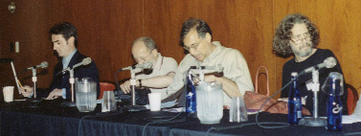
Mark Dery, Jim Carey, Paul Thaler, Hal Himmelstein—part of the roundtable on the future of news.

McLuhan
We can place the specific examples and findings of scholars like Birdwhistle, Goffman, and Marx into a McLuhanesque context of media as environments.
Joshua Meyrowitz, University of New Hampshire

The usual scholarly strategy is to strip words of multiple meanings, define them precisely. But McLuhan reveled in puns and poetry--he stretched meanings of words.
Joshua Meyrowitz, University of New Hampshire

Call for Papers and Panel Proposals for the
MEA Program at the 2002 Annual Convention of
the National Communication Association
November 21-24,
New Orleans Sheraton & New Orleans Marriott

The Media Ecology Association (http://www.media-ecology.org/) invites submissions of competitive papers, panel programs and other innovative programs addressing theoretical, research, and/or methodological issues in Media Ecology. These may include the study of the role of technology and techniques, modes of information and codes of communication in human affairs (e.g., language and culture, technology and culture, orality and literacy, medium theory, the symbolic structure or grammar of communication media and its implications, etc.).

Each complete paper submission must include:
(1) a detachable title page with the title of the paper and author name, address, institutional affiliation and e-mail address;
(2) a separate 50-75 word abstract with the paper's title.
Program proposals should include:
(1) a properly completed NCA 2002 convention proposal form (downloadable
from http:///www.natcom.org/);
(2) a thematic title for the program;
(3) a rationale for the program;
(4) a title and abstract of each paper to be presented; and
(5) names, addresses, institutional affiliations of all participants.
(6) For panel proposals, please also send a PC-formatted floppy with the document's file on it (Word or WordPerfect for Windows).
Five hard copies of completed papers or panel proposals should be sent (to arrive by February 1, 2002) to
Casey M.K. Lum, MEA/NCA Program Planner,
Department of Communication,
William Paterson University, Hobart Hall,
300 Pompton Road, Wayne, New Jersey 07470-2103.
Submissions received after the February 1, 2002 deadline will not be accepted.

Casey M.K. Lum, Ph.D.
Voice/Fax: 1-718-380-0392 E-mail: casey.lum@nyu.edu

Members’ News
Jack A. Barwind (jbarwind@syr.edu) writes: I am leaving Syracuse University. I have taken a position as a Professor of Communication and Media Studies at Zayed University in the United Arab Emirates. I am hoping to spread the media ecology mantra to the UAE. Orientation begins August 2 with classes beginning the 1st of September. I am fascinated with the prospect of being a part of a developing program with a strong focus on communication competency (professional competency) in an underrepresented group. Zayed University is a State supported women's university. The fact that this university exists in an Islamic State in the Middle East is a tribute to the progressive forces operating in the United Arab Emirates.

Bruce E. Gronbeck (gronbeck@blue.weeg.uiowa.edu) writes: The College of Liberal Arts and Sciences at the University of Iowa has recently authorized the establishment of the University of Iowa Center for Media Studies and Political Culture, under the directorship of Bruce Gronbeck. The center will foster scholarly and instructional work focused on institutional and non-institutional politics in the electronic age; provide co-editorial management of the "Frontiers in Political" book series at Peter Lang; take over management of most of Communication Studies Resources links; and prepare to launch an electronic journal for works on political culture that can profit from hyperlinks and digitized photo and video materials. As well, it has a bid in to serve as editor of an e-democracy listserv, the Iowa Political Forum. Watch for developments at http://www.uiowa.edu/~policult

David Linton, (dlinton@mmm.edu) of Marymount College writes: I was recently interviewed by a reporter from LINGUA FRANCA about pornographic treatments of Shakespeare's plays, one of my specialties. (The article appeared in the Sept., 2001 issue, pp. 8-9, “the Pound of Flesh”.)

Gregory Reynolds, (greynolds@fcgnetworks.net) pastor of Amoskeag Presbyterian Church in Manchester, NH, writes about his new book: THE WORD IS WORTH A THOUSAND PICTURES: PREACHING IN THE ELECTRONIC AGE. It seeks to integrate media ecology with historic Christianity in developing a homiletical theory which will enable pastors to be more effective communicators. It assesses the work of theorists such as McLuhan, Ellul, Ong, Postman, and Meyrowitz. Retail price $47.50 - Wipf and Stock Publishers, 2001 - ISBN: 1579106382 504 pages with extensive annotated bibliography, subject, author and Scripture indexes. Available directly from author for $38 postpaid, contact author at reynolds.1@opc.org.

Pamela Peeters (pamela_peeters@hotmail.com) has started her own eco-consulting company and web site, working on redesigning information for sustainable development.
W:http://www.our-planet.org T:212-8548197

Frederick Wasser, (WasserF@mail.ccsu.edu) of Central Connecticut State U. writes: My book VENI VIDI VIDEO: THE HOLLYWOOD EMPIRE AND THE VCR has a December 2001 release date from University of Texas Press. $22.95 ISBN 0292791461

President’s Message (cont.)
• Program Formats. What is the optimal program length? The standard hour and fifteen minutes? Something longer, or shorter? Or are sessions of different lengths desirable? Is program time best devoted to the presentation of papers? Should programs include respondents or discussants? Is more audience interaction needed? Are roundtable discussions a worthwhile format? Should we use interactive sessions or poster sessions for some of the papers submitted (a format where authors are given space instead of time, and the audience members visit with the authors for one-on-one discussion or small group interaction)? Should we use such a format for displays of media production? Are there other formats worth considering? And then there is the agonizing question: Should we consider going to concurrent sessions, even on a limited basis? There is a wonderful sense of unity that exists when there are no competing sessions, and of course the audience size tends to be greater than it otherwise would. On the other hand, parallel sessions may allow for greater participation and less of a time crunch
• Attendance. For the moment, our goal is to increase attendance. A very important question is how closely is attendance tied to participation? How many people will only come if they are presenting a paper? And how best can we accommodate such needs without compromising the process of evaluating papers and proposals? Alternately, would opportunities to chair a session or respond to papers make it possible for some to attend? And how can we maximize the number of people attending but not participating?
• Diversity. A preoccupation of our times, diversity is a multidimensional factor for the MEA. We need to consider gender, race, ethnicity, and religion, of course. We also need to think about age and status, i.e., how can we increase the number of students who attend our conventions? Admittedly not an easy task, given the time of year of our convention, but not an impossible one either. Another consideration is professional diversity. We are a scholarly organization, but we have had participation from journalists, artists, writers, and government officials in the past, and we must continue to reach out to these and other constituencies. One further element is geographic diversity. How best do we encourage participation from all corners of the globe? This brings me to the final factor:
• Convention site. Our Third Annual Convention will mark our third year in a row in New York City. Should we continue to build on a successful series of events in the Big Apple before taking our show on the road? Or are we being parochial and ultimately preventing our organization from growing in size and diversity? Within the New York Metropolitan Area, is Manhattan the only viable location, or are host institutions in the outer boroughs or suburbs a possibility? Outside of New York, what other locations are desirable and available? Are there alternatives to relying on universities as host institutions? We will be making our decision for the 2003 convention by the end of the year, and will start to think about 2004. On this matter, I invite not only feedback but also serious inquiries from potential hosts.
You can communicate your input and feedback privately to me by e-mail <Strate@Fordham.edu>, telephone <(718) 817-4864>, or letter <Department of Communication and Media Studies, Fordham University, Bronx, New York 10458>, or post it for further discussion on the media ecology listserv.
Call for Nominations for Election to the Board of Directors
"Any member of the Association in good standing may also nominate any other member in good standing, or self-nominate, for membership on the Board of Directors.” The cut-off date for accepting further nominations is 5 p.m. (Eastern Standard Time) on September 21, 2001. Bill Petkanas has been appointed Chair of the Ad Hoc Nomination Committee. Please send your nomination by the cut-off date via e-mail or by mail to: Bill Petkanas, Department of Communication and Theater Arts, Western Connecticut State University, 181 White Street, Danbury, CT 06810. His e-mail address is petkanas@wcsub.ctstateu.edu and he can be reached by telephone at (203) 837-8255.

[The images used herein were obtained from IMSI’s MasterClips® and MasterPhotos® Premium Image Collection, 1895 Francisco Blvd. East, San Rafael, CA 94901-5506 USA.]

